PRESENTATION OF THE SCOUTMASTER CAMPAIGN COVER
SCOUT 1: Attention all hands for award presentation! The success of our Troop comes from the effort of all team members, from the Boys as leaders, to the Scoutmasters, to the Committee Members and other parents helping to organize trips, camp outs, and fundraisers. Today, we would like to thank our Scoutmaster for his countless hours over the past few years. The adage a scoutmaster spends 8 hours per week is probably closer to 20 hours per week when you factor in all the weekend campouts, coordination and planning, and paperwork. From all of us, we present you with one of the oldest symbols of a true scout leader, the CAMPAIGN COVER.
SCOUT 2: A little about the history of this campaign cover. The origins of this type of hat can be traced to the 1840s when U.S. Army mounted troops posted to the far-west sometimes wore wide-brimmed civilian hats, which were more practical than the regulation shakos and forage caps then issued. The crease was influenced by the designs of the sombreros worn by the Mexican Vaqueros. The name started to be used after 1872 which introduced a black felt hat, and after 1883 could be drab color during the American Civil War. At this time, the campaign hat was not stiff like the current version.
SCOUT 3: Around 1893, the famous cowboy hat maker Stetson made a Campaign Hat named “Boss of the Plains” which was being creased into pointed tops by the British Scout Africa Company (BSAC) in Africa. This is where Sir Baden Powell was working with the scouts and British Army in the 1890s. He met an American, Frederick Russell Burnham, who was the Chief of Scouts and worked with the British Army who wore the Stetson Campaign Hat. Baden-Powell like it so much, he ordered 1200 for the Canadian troops serving under him, then ordered another 10,000 hats for the British.
SCOUT 4: Around 1911 the US Army adopted the hat during the Spanish American War. Through WWI, the hat was fairly soft. US Army General Officers had a golden cord, and other officers wore golden and black cord. Field clerks wore silver and black, and eventually the Marines started wearing them. In 1930’s, the felt hat was made stiff with permanent brim.
SCOUT 5: To close the loop back on scouting history, Baden Powell picked up the habit of wearing a Stetson campaign hat and neckerchief for the first time in 1896 in Africa during the Second Matabele War. In the African hills it was Burnham (the American that wore the Stetson Campaign Hat) who first introduced Baden-Powell to the ways and methods of the indigenous peoples of the Americas, and taught him woodcraft (better known today as Scoutcraft). Baden Powell may have been influence on the campaign cover since the “Boss of Plains” style hat was also abbreviated BP, which was also his initials. When Baden-Powell re-wrote his Army handbook Aids to Scouting into Scouting For Boys in 1908, he included sketches of Boy Scouts wearing the campaign hat. He prescribed a campaign hat as part of the Scout uniform, which he stated was "very like the uniform worn by my men when I commanded the South African Constabulary". He continued; "...The broad brimmed khaki hat is a good protection from sun and rain."
SCOUT 6: In the original scout handbook, Sir Baden Powell wrote that the Campaign Cover is to be worn square with the floor, unlike the current Drill Sergeants. Current BSA Regulations state that the Scout Universal Hat Pin should be worn. Wear it as a symbol of our pride in the Boy Scouts! [APPLAUSE]

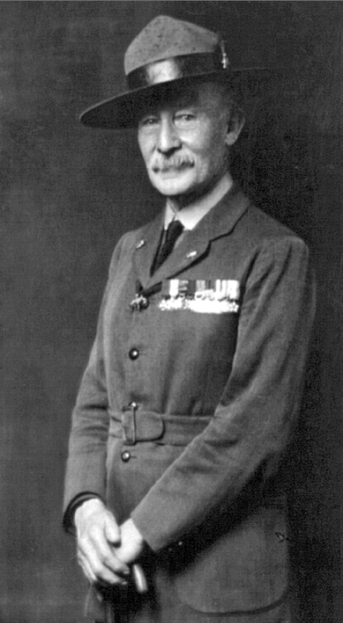
Sir Robert Baden-Powell founder of the Scouting movement for boys, wearing a British Scout uniform and an American Stetson campaign hat
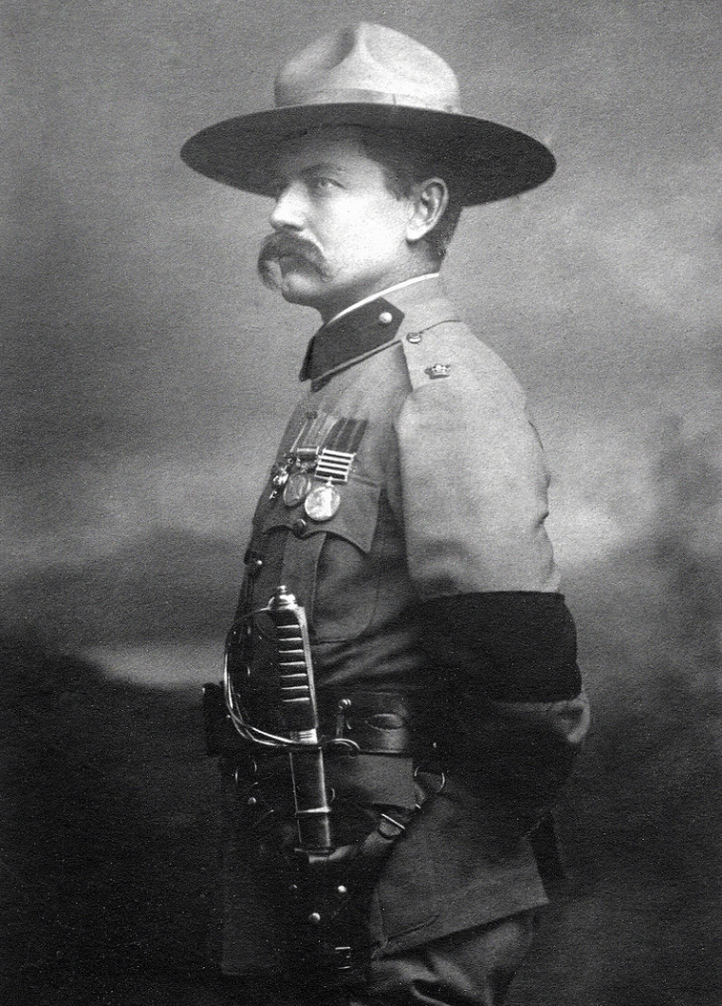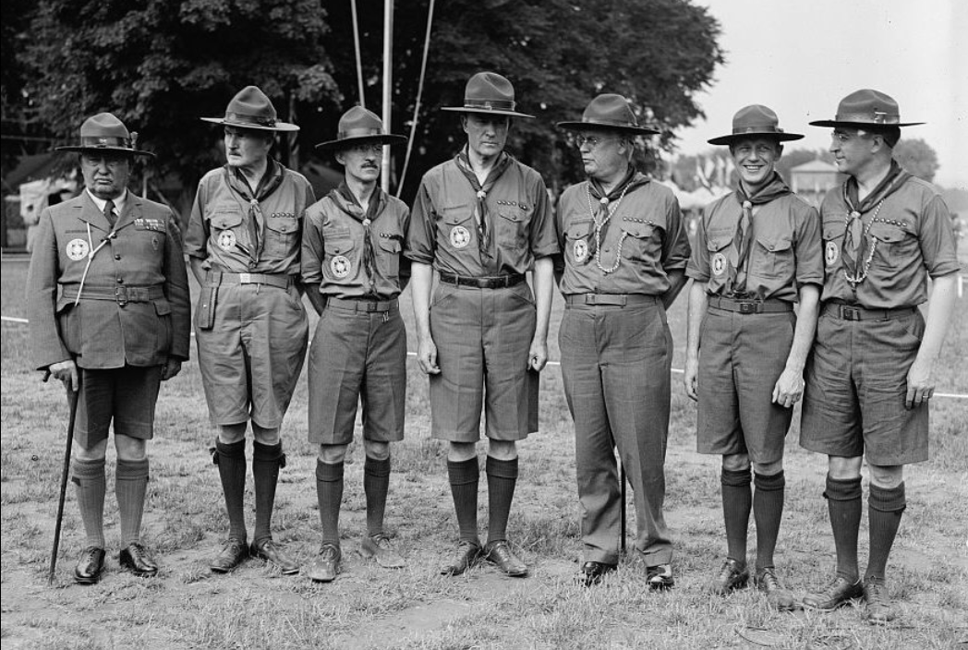
Adult leaders of BSA at the first US National Scout Jamboree at Washington DC in 1937
American scout Frederick Russel Burnham wearing a campaign hat in 1902 after the Second Boer War. He introduced scouting and American woodcraft to Baden-Powell in 1896.

