

Venturing Crew 2828

Planning a Backpacking Trip



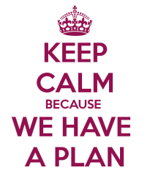

A Word on Planning

In the 5th century B.C., the Chinese Philosopher Lao Tsu wrote, “Do the difficult things while they are easy and the great things when they are small.” That advice is the essence of planning and preparation. Take care of as much as you can while in the comfort of your home, and then you can set off for the field knowing you’ve done your best to prepare. After that, it’s simply a matter of fully experiencing the backcountry when everything goes according to plan, or being able to adapt to changing circumstances when the original plan no longer applies.

*From the Boy Scout Field Book*

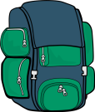

Table of Contents and Time Line

**Page #**

**Trip Planner Responsibilities**……………………………………………………………………………………………………………………… 4

*2-4 Months Out:* **Selecting the Route**…………………………………………………………………………………………………………… 5

*1-12 months out:* **Assessing Interest**…………………………………………………………………………………………………………….. 10

*1 month out:* **Assembling the Team and Assigning Duties**……………………………………………………………………………. 11

*2 weeks to a month out:* **Meal Planning**……………………………………………………………………………………………………….. 15

*2 weeks out:* **Arranging Transportation** ………………………………………………………………………………………………………. 21

*1-2 weeks out:* **What should be in you backpack, and how to pack it**…………………………………………………………. 24

*One week out*: **On the Trek—READ BEFORE THE HIKE**

**Bear Bags**………………………………………………………………………………………………………………………………………… 30

**“Going,” in the woods**………………………………………………………………………………………………………………………. 33

**Camp set-up**…………………………………………………………………………………………………………………………………….. 34

**Water Purification**…………………………………………………………………………………………………………………………… 35

**Backpacking Stove Operation**…………………………………………………………………………………………………………. 36

**SEMPER GUMBY**!!!!........................................................................................................................................ 37

Appendix A: Venturing Risk Management Plan……………………………………………………………………………………………. 38  
Appendix B: BSA Medical Forms………………………………………………………………………………………………………………….. 39

Appendix C: Platypus Filtration system instructions…………………………………………………………………………………… 39

Appendix D: Whisperlite Stove Manual from MSR……………………………………………………………………………………… 39

**Other Resources**…………………………………………………………………………………………………………………………………………... 40

C:\Program Files (x86)\Microsoft Office\MEDIA\CAGCAT10\j0291984.wmf

**Trip Planner Responsibilities**

The trip planner is responsible for the overall completion of a trip. He or she will have other duties before and after the trip, but their primary responsibility is to make sure that that all of the separate trip planning jobs get done. This is an ongoing process. It does not just happen once. You must regularly reassess to make everyone is taking care of their share of the duties.

In addition to assigning duties for before, during, and after the trip, the trip planner needs to make sure a couple of important meetings occur:

1. The trip planning meeting: In this meeting the trip is discussed, and meals can be planned and duties can be assigned.
2. The shakedown meeting: In this meeting which may sometimes not be necessary, new backpackers are assessed for their readiness for the trip. That is, we make sure that they have the proper pack and equipment for the trip.

**Costs**: Trip planner also needs to assess per person costs for trip, and communicate the fee to the group that is hiking.

The cost calculation is as follows:

Fees (total fees divided by number of hikers): $_____

Meals: $3.00 for breakfast, x# of breakfasts, $ 4.00for lunch, x# of lunches,

$5.00 for supper/dinner, x# of suppers +$_____

Equipment use fee (used to maintain and replace equipment, fuel, water purification supplies, etc): +$5.00

Total per person: ______

**IMPORTANT NOTE:** After food costs have been calculated, you must multiply per person cost by number of people and communicate this food budget to the Grubmaster (meal planner).

.

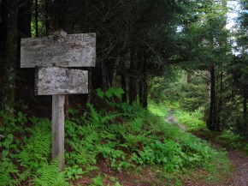

**Selecting the Route**

Selecting the route can be done by the trip planner or someone else. Keep in mind: adult resources for route selection are Mr. Mallia, Mr. Nelson, Mr. Weir, and Mr. Brower. All four of them are very happy to help you with this task, and usually have lots choices available for you.

Things to consider:

* How exactly do you intend to get to the start of your trek and home again once you have finished?
* How many days and nights will the trip be? How long does it take to get to the trail head? When are you planning on getting there? All three of these factors can be very closely dependent on each other and need to be considered together.
* What passes, licenses and related documentation are required for the trek by the are you are visiting?
* Are there special rules for the particular place that we are visiting? For instance, are there limits on number of people that can hike together? Number of people that can camp together? Are there rules about fires? etc.
* What route do you intend to take and why – what is the purpose of the trek, what do you want to see, why are you going, what topographical features will you have to negotiate and do you have the skills to negotiate them?
* Do you have a safe emergency egress route should things go wrong? Where is the nearest hospital(s)?
* Where do you intend to sleep – will you be camping and if so, where and is it legal to camp wild? Do you need to book huts or other accommodation in advance? Is the popularity of a given route seasonal – if so, book well in advance
* What weather, terrain and conditions are likely to be experienced on the trek? Can you deal with ANY GIVEN SITUATION – if not, you may want to reconsider whether it is safe to go.
* What gear do you need to be safe, and what gear do you need to be comfortable and what gear do you need to enjoy your time there?

Some starter ideas for general locations:

* Monongahela National Forest (Otter Creek Wilderness, Dolly Sods wilderness, Cranberry Wilderness, etc.)
* Shenandoah National Forest
* Appalachian Trail
* Laurel Highlands (Pennsylvania)
* C&O canal
* Washington National Forest
* And wherever else you want to go!!!

Once you decided in general where you are going, you need to figure out some **possible routes**. To do that you need to:

1. Get a map: Maps come in many, many different flavors. Keep in mind that map should provide you and fellow hikers with readable accurate route information, information about other connecting trails, elevation changes (topographical information), landmarks, and hopefully campsites. Source for maps include national and state park web sites, national and state park forests. There are many sources of topographical maps. One source that is commonly used, but can be tricky to search, is the U.S. Geological Service: <http://nationalmap.gov/ustopo/> <https://www.usgs.gov/products/maps/topo-maps> . National Geographic has nice, free, downloadable topographic maps here: <http://www.natgeomaps.com/trail-maps/pdf-quads> . Midatlantichikes.com (<http://www.midatlantichikes.com/>) is another great source of topographical hiking maps and notes about the hike. You should also try to google the trail name (+ and – the word “map”), and you can often get lots of maps and information about the trail. Google is your friend!!! The web is your friend!! Use it!
2. Read a map: too much information to cover in this guide, but two extremely useful resources are the Scout Handbook (in the 13th edition, The Navigation Chapter, pages 326-357) and the Scout Field Book (Navigation Chapter, pages 97-113)
3. Will it be a loop hike or linear hike?: Linear hikes are easier to plan design in certain ways, but you then need to figure our way to get back to the trail head. For example: is there some kind of public transportation that will take you back to the front of the trail? Can you arrange a pick-up from parents who are not going to transport some people back to the beginning of the trail? Or maybe the parents can pick everyone up at the end and take them home at the end of trail (this saves a lot of time).

Once you have selected a route, now it’s time to do some **calculations**. Sometimes this may cause you to rethink your route. This is Ok, and part of the process:

How long will it take? : In general, **as an estimate**, you can count on 2 miles per hour on flat land. Reduce that a bit for every 1000 feet above your home elevation due to reduced oxygen. To the total time, add 1 hour for every 1000 foot elevation change due to slow climbing.

In order to figure out how long it will take, you need to check the terrain on your route. Use a detailed topographic map to understand the difficulty of your hike. It may just be a 6 mile loop on the map, but that may be flat or include 4000 feet of elevation change. Also make sure your map is current – trails can sometimes change. The elevation you gain and lose while hiking will have a definite effect on how fast you hike and how much ground you cover. Hiking up a steep grade will slow you way down, forcing your muscles to work much harder. Hiking a downgrade will be easier on muscles but much harder on joints.

An excellent resource on planning your hike with distance an time can be found here: <http://www.outdoorblueprint.com/read/estimate-your-hiking-travel-time/>

**When you have a route, create a timeline with distances and times of the hiking route (you can change or adapt this chart as needed)**

|  |  |  |  |  |  |  |  |  |
| --- | --- | --- | --- | --- | --- | --- | --- | --- |
| **Mrkr** | **Features** | **Description** | **Seg Mi.** | **Daily Cum. Mi.** | **Seg Elev. Chng.** | **Trip Mileage** | **Elev.** | **Actual Time** |
| 0 |  |  |  |  |  |  |  |  |
| 1 |  | " |  |  |  |  |  |  |
| 2 |  |  |  |  |  |  |  |  |
| 3 |  |  |  |  |  |  |  |  |
| 4 |  |  |  |  |  |  |  |  |
| 5 |  |  |  |  |  |  |  |  |
| 6 |  |  |  |  |  |  |  |  |
| 7 |  |  |  |  |  |  |  |  |
| 8 |  |  |  |  |  |  |  |  |
| 9 |  |  |  |  |  |  |  |  |
| 10 |  |  |  |  |  |  |  |  |

Elevation Chart (you can change or adapt this chart as needed)

|  |  |  |  |  |  |  |  |  |
| --- | --- | --- | --- | --- | --- | --- | --- | --- |
|  |  |  |  |  |  |  |  |  |
| Elevation |  |  |  |  |  |  |  |  |
|  |  |  |  |  |  |  |  |  |
|  |  |  |  |  |  |  |  |  |
|  |  |  |  |  |  |  |  |  |

0 1 2 3 4 5 6 7 8 9

Miles

**ONCE A ROUTE IS PERMANANTLY SELECTED, AND THE TRIP PARTICIANTS ARE KNOWN**

**At some point, create a map of hiking and driving routes on Google maps**—See Mr. Nelson for help with this part. This is done for every hiking trip.

**Create a Backpacking Trip plan:**

Once you planned these elements of the trip, you should be ready to prepare a trip plan. Take a copy of your trip plan with you and leave one with your parents or other adult. The parts of a trip plan are:

* WHERE are you going? Decide on your destination and the route you will travel to reach it and return. For backcountry trips, include a copy of the map with your route marked in pencil.
* WHEN will you return? If you are not back reasonably close to the time on your trip plan, someone can take steps to locate you and provide assistance if needed.
* WHO is going on the hike? List the names of your hiking partners. Know who will transport you to the trailhead (see transportation plan later in this manual).
* WHY are you going? Going fishing, climbing a mountain, exploring a new area are all good reasons for a hike. Write a couple sentences about the purpose of your trip.
* WHAT are you taking? Carry the Scout outdoor essentials and list other equipment and clothing you will need.
* HOW will you respect the land by using Leave No Trace hiking skills?

The form on the next page should be completed for each backpacker:

**TRIP PLAN**

Scout Name: ______________________

Departure Date and Time: ______________________

Estimated Return Date and Time: ______________________

Destination: _____________________________

Route Going: _______________________________________________________________________

__________________________________________________________________________________

__________________________________________________________________________________

Route Returning: ____________________________________________________________________

__________________________________________________________________________________

__________________________________________________________________________________

Distance Going: ____________

Distance Returning: ____________

Others on Hike: _______________________________________________________________

Purpose of Hike: _______________________________________________________________

__________________________________________________________________________________

Special Permissions or Permits Needed: _________________________________________________

__________________________________________________________________________________

Sources of Drinking Water: ____________________________________________________________

__________________________________________________________________________________

Equipment Needed (can also attack checklist):

_____________________________ _____________________________ ___________________________

_____________________________ _____________________________ ___________________________

_____________________________ _____________________________ ___________________________

_____________________________ _____________________________ ____________________________

_____________________________ _____________________________ ____________________________

_____________________________ ______________________________ ____________________________

_____________________________ _____________________________ ___________________________

_____________________________ _____________________________ ___________________________

_____________________________ _____________________________ ___________________________

_____________________________ _____________________________ ____________________________

_____________________________ _____________________________ ____________________________

_____________________________ ______________________________ ____________________________

Clothing Needed (can also attached checklist):

_____________________________ _____________________________ ___________________________

_____________________________ _____________________________ ___________________________

_____________________________ _____________________________ ___________________________

_____________________________ _____________________________ ____________________________

_____________________________ _____________________________ ____________________________

_____________________________ ______________________________ __________________________



**Assessing Interest**

To have a trip, you need to gather interested people. This can be one of the most challenging parts of arranging the trip, but everything else depends on this part.

The most important thing to remember here is that you need to sell this trip! Let people know what is it about, what are the interesting things they will see, or if there is some interesting history of the area. What are they going to get out of this trip?

Next, you have to get the word out and get firm commitments. **All forms of communication are acceptable**, but the most important thing is to collect definitive, reliable information about who is going on the trip. Possible ways are texting and emails. You will probably have to use multiple methods, and ask people more than once.

**Venturing Web Page Group e-mail:** The way to send an email to the entire crew is through the Crew **Scoutlander** Web Site (<http://vscrew2828.scoutlander.com/publicsite/unithome.aspx?UID=29826>). Mr. Mallia and Mrs. Williams can show you how to do this.

A brief overview of the procedure:

* 1. Click on website, and sign in as a member
  2. Click on “Broadcast System” on left hand side menu
  3. Follow steps on next page: “add all”, ignore step 2, attach something in step 3 if you need to, and fill in your message in step 4, and click on Send Now button.

**On-line sign up:** At the same time you are determining interest you should arrange to have a trip signup sheet posted online, at the Venturing Crew **Google** site—this can be done by consulting with Mr. Nelson. You should have information about dates, fees, and location of trip when you do this.

Keep in mind you must have two adults going on each trip, and you must one of each gender of Venturer that is going if it is an overnight trip.

**IMPORTANT NOTE:** It is less important HOW you find out who is going than the fact that you find out, definitively. You need to contact everyone, and not leave people out. And you need to make sure you have firm commitment from Venturers AND adults! These things are absolutely essential!

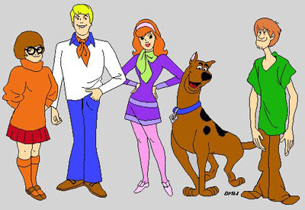

**Assembling the Team and Assigning Duties**

Once you know who is going, you can start to organize the team and their duties. **Please Note:** Certain duties can be simultaneous. In other words, one person can have two different duties on the same day, depending on how much that duty entails. For example, the person who is responsible for trash can also be Firemaster on the same day. Quartermaster, who has major duties before and after the trip can do a couple of minor duties during the trip. Please also note: **This must be done well in advance of the hike.** This allows everyone to prepare for their duties. Also, crew members feel that the process is fair, and the work is evenly distributed.

Duty Descriptions:

**Navigator**: Responsible for leading the hike for whatever section of the hike they are assigned. There may be more than one navigator per day. Navigator should have a readable, functional map that is protected from the elements (zip-lock bag or other means), and a compass. They should familiarize themselves with the route WELL BEFORE the hike so that questions or issues can be taken care of ahead of time. As a general rule, all crew members should have a weather-proof map and be familiar with the route, to prepare for the trip.

**Water treatment:** Responsible for treating water purification and for figuring out how much purified water will be needed each day.

**Site setup**: Responsible for figuring out the best arrangement of campsite—For example, where tents go where kitchen and sump will be, where backpacks will be, etc.

**Stoves/Fuel/Firemaster**: responsible for setting up stove and preparing a campfire (if allowed).

**Cook**: cooks meal(s)

**Cleaner-upper(s)**: cleans dishes and kitchen after meals.

**Bear bag hanger(s)**: Find(s) bear bag location and set(s) up bear bag.

**Trash**: sets up trash bag and maintains a tidy campsite.

**Quartermaster**

Before Trip:

* + - * Use crew gear inventory sheets (see page 29 for a copy) to make sure all of the crew gear is there. Boxes around items on the inventory sheet mean they are grouped together - example: The Roux Spoon (flat bottom spoon) should be in the Kitchen Ditty bag.
      * Make a note of items that are missing.
      * Make sure all gear is completely clean. Rinse all Nalgene bottle thoroughly with water.
      * Make sure all gear is functional. Check stove to make sure it is working, and check to see if fuel bottle is full. If not, fill it with more white gas

During Trip:

*Before hike:* Check out crew gear to crew, while trying to evenly distribute it between crew members. Make a note of who has what gear on inventory sheet. This person is responsible for this gear for the duration of the trip.

*After hike:* Check all gear back into inventory using inventory sheet, making notes about broken or missing items.

After Trip:

* + - * Use the crew gear inventory sheets to organize the crew gear back in order. Boxes around items on the inventory sheet mean they are grouped together - example: The Roux Spoon (flat bottom spoon) should be in the Kitchen Ditty bag.
      * If any part of the crew kit is dirty - clean it.
      * Make a note of items that need to be replaced or missing and restock the crew gear boxes (you will be reimbursed).
      * Wash off the outside of the 3 liter Nalgene bottles removing dirt and debris.
      * To rinse inside of 3 liter Nalgene bottles: rinse the inside with 1/4 cap full of bleach (be careful with the bleach) and water to the fill line. Shake and let sit up right for an hour. Re-shake and lay on its side for an hour. Drain out the water/bleach mix. Rinse a few times with about 1/2 liter of water to get rid of the bleach smell. Dump out excess water. Let bottles sit for 24 hours (in the sun if possible) to dry out.

**Crew leader**: makes sure all operations are running properly and attends to the needs of the crew.

**Assistant Crew Leader**: Assist crew leader in his or her duties

**Duty Roster**

**(All boxes must be filled out. Make two copies of this and post one at campsite)**

|  |  |  |  |
| --- | --- | --- | --- |
| **Job** | **Friday** | **Saturday** | **Sunday** |
| Navigator |  |  |  |
| Water treatment |  |  |  |
| Site setup |  |  |  |
| Stoves/Fuel/Firemaster |  |  |  |
| Cooks |  |  |  |
| Cleaner uppers |  |  |  |
| Bear bag hangers |  |  |  |
| Trash |  |  |  |
| Crew leader |  | | |
| Assistant Crew Leader |  | | |
| Quartermaster |  | | |
| Grubmaster |  | | |

**Tent mates**—This is not a “duty” but tent-mates need to be known ahead of time, to make sure pack weight is conserved and needs for tents are covered. The usual number of people per tent is two, *occasionally* three, and some people bring hammocks. Those bringing hammocks must be sure: 1) no tent-mates are needed, and 2) the area where you are camping can accommodate hammocks.

Trek Crew/Adult Tent Mates

|  |  |  |
| --- | --- | --- |
| Tent | **Tent Mates** | **Status—who is bringing the tent?** |
| 1 |  |  |
| 2 |  |  |
| 3 |  |  |
| 4 |  |  |
| 5 |  |  |
| 6 |  |  |
| 7 |  |  |
| 8 |  |  |
| 9 |  |  |
| 10 |  |  |
| 11 |  |  |
| 12 |  |  |

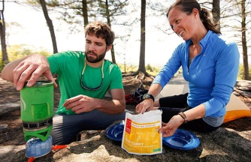

**Meal Planning**

Planning the Crew meals is very important duty and should be taken very seriously. A good meal can be a giant boost for crew morale after a long day of hiking. Below are some guidelines for planning crew meals.

The general method: **1)** Plan meal with your fellow backpackers (record choices in the meal plan on page 17), making sure to note allergies. **2)** Purchase food within in the food budget (will be given to you by the trip planner). **3)** Place food into zip lock bags. **4)** Distribute food bags just before getting on the trail.

Some important additional notes on meal planning and preparation:

Try to plan meals that are somewhat balanced nutritionally. Backpackers need a combination of protein, fats, complex carbohydrates, and maybe a few simple carbohydrates to meet their energy needs. See the discussion of this on pages 40-41 of the BSA Fieldbook, (5th edition), and pages 81-83 of your BSA Handbook (13th edition). Although having fresh vegetables and fruit is a little difficult for the trail, it would be good to have some form of these during the trip.

**Food Allergies must be sent and communicated to the grubmaster.** Please list ingredients to avoid and “safe” food types and brands. The Grubmaster needs to proactively check with crew members that have food allergies and visa versa -this is a shared responsibility!

Some sample backpacking meals can be found on the pages following the Trek Meal plan sheet. There are many, many, more ideas on the internet.

Food should be light weight, crush proof, and easy to clean up. Please only bring food to be hydrated/boiled/reheated. No pan frying bacon for example. You might want to practice cooking and CLEANING UP YOUR MEALS to see if they are good trail meals.

Another important consideration for your meals is quantities. If you bring too much, this is more weight to carry for the entire trip. Also, whatever is made for dinner must be eaten entirely, so you don’t want to cook more than people can eat. On the other hand, if you bring too little food, you crew-mates will go hungry, which is in general not a good thing for hiking, and it hurts crew morale. Read more about how to assess food quantities on pages 39-48 of the BSA Fieldbook, (5th edition), and pages 290-300 of your BSA Handbook (13th edition). These books have two very different approaches and you should read **both** to determine food estimates.

Again, in order make sure your meal comes out successfully, it is a good idea to make the recipe at home, preferably using a backpacking stove. This will let you know better about cooking times, the right amount of water to add, if ratios are right, if different/more seasoning is needed, if special cooking equipment is needed, etc.

Taking food out of its packaging before distributing can save a lot room. Just be sure to include cooking instructions if needed, or ingredient lists if allergies are a concern.

Plastic Zip Lock Bag Method: Our crew uses the “plastic Ziploc bag method.” Here is how it works: Pack all food items in one large Ziploc bag per 2 crew members, with a copy of the menu. Each Zip lock bag should be labeled with meal name and day number. Unless there are allergy issues, these bags can be randomly distributed, along with crew gear.

Each meal should contain enough for two people. Sometimes there can be 2 of one type of item, or 4, or sometimes you may have something large enough so it can be split in two. Food does not need to be exactly the same for the two people sharing.

Here’s a picture of what the prepped meals should look like. This is an example and these bags don’t contain complete meals:

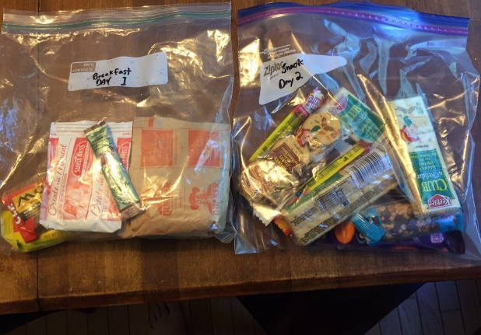

Supper can be a little different: in this case you may have some items that are going to be combined together, in a pot, for example, for a large group meal. In this situation, supper meals should be taken out by the group at once, and components that need to be combined can be combined, before the rest of the meal is shared.

Here are some supper ideas from the BSA Field Book. There are more ideas following the Trek Meal Plan, and on the internet:

Trek Meal Plan

|  |  |  |
| --- | --- | --- |
| **Crew Size:** | **Description** | [**Meal Suggestions HERE!**](https://drive.google.com/folderview?id=0BwvBTrONqO7rUE5FUlRWRVBiT3M&usp=sharing) |
| ***Friday Snack***  ***Saturday Breakfast*** |  |  |
|  |  |  |
|  |  |  |
|  |  |  |
|  |  |  |
|  |  |  |
|  |  |  |
| ***Saturday Lunch*** |  |  |
|  |  |  |
|  |  |  |
|  |  |  |
|  |  |  |
|  |  |  |
|  |  |  |
| ***Saturday Dinner*** |  |  |
|  |  |  |
|  |  |  |
|  |  |  |
|  |  |  |
|  |  |  |
|  |  |  |
| ***Sunday Breakfast*** |  |  |
|  |  |  |
|  |  |  |
|  |  |  |
|  |  |  |
|  |  |  |
|  |  |  |
| ***Sunday Lunch*** |  |  |
|  |  |  |
|  |  |  |
|  |  |  |
|  |  |  |

An example of a crew meal plan is below. Double click to open file:



**Backpacking Recipes**

Listed below are just a few backpacking recipe ideas. The internet contains an almost infinite supply of additional ideas. The web is your friend!!!

**Super-Easy**

Spicy Tuna and Rice

For each person:

I package Starkist Tuna Creations Sweet and Spicy Single serve (2.6 oz)

1/2 pkg Uncle Ben’s Ready Rice (8.5 oz.)

2 tablespoons water

1 soy sauce packet (optional)

hot sauce/sriracha to taste

Add tuna and water and heat after mixture is warm, add rice and stir. Add soy sauce and/sriracha to taste.

Can also be mixed without heating.

Chicken noodle soup

For each person:

Add 1 small can of chicken (with juice) to ½ cup of water and bring to a boil. Carefully add one packet of Lipton Cup-A-Soup while stirring. Cook for 30 seconds.

Beanie Weenies

I large can of Baked Beans (about 28 oz)

2 cans of Vienna sausage

Drain Vienna sausages. Add to baked beans and heat. Serves 2-4 people

**Easy**

Trail Tacos

10 Tortillas (Corn or flour)

Refried beans (canned or dehydrated. Dehydrated needs to be rehydrated ahead of time. “Flavored’ refried beans are preferable)

Beef Jerky

Cheese (real or dairy free)

Uncle Ben’s Ready Rice--Spanish Rice (optional)

Rehydrate beef jerky by added I cup of water to package, double zip lock, and let sit for about 4 hours. Note-Rehydration is not essential.

Put tortilla in a hot pan and heat for 30 seconds, or as long as it takes for the chees to start to melt. Add beans, cheese and/or beef. Serves 2-4 people.

Chicken Onion Meal (from Cooking Merit Badge book)

1 small can chicken

1 cup dry instant rice

1 packet dry onion soup mix

Before leaving, put the rice and soup together in a resealable plastic bag. In camp, add 1-and1/2 cups of water to a pot and start it boiling. Add rice to mixture. Stir in the chicken and warm the mixture over the stove burner.

Chicken and….

I large can of cooked chicken

½ container of chicken stock (or 1 Bullion cube)

+ 1 and ½ cups of water +

2 rice vermicelli bundles OR

1 package ramen noodles, broken up (including flavor packet) OR

Rice noodles (e.g. Kame brand Express Rice Noodles), I package OR

½ cup of uncooked minute rice

Add chicken, water, and stock. Heat to boiling. Boil, while stirring for 3-5 minute.

Beans, Rice and Ham

1 16 oz. can of ham (e.g. DAK brand) or 1 12oz. can of Spam

2 cans of black beans seasoned, (or unseasoned, and add seasoning later)

1 cup of minute rice

2 cups of water

2 tablespoons olive oil (optional)

½ teaspoon garlic powder (optional)

½ teaspoon cayenne pepper

Salt to taste

Cube ham and boil water. Add rice and boil for 3 minutes. Add beans, ham, and spices, and heat to warm up. Serves 4-6.

Macaroni and Cheese

Kraft Macaroni and Cheese “Easy Mac” (Must be this style)

Water

For each person:

Add ½ to 2/3 cups of water to pot

Add one macaroni pouch.

Bring water to boil, and boil for 2 minutes.

Add cheese sauce pouch and stir.

To make this more filling:

Add one of tuna, or chicken, or cubed spam for every 2 servings

Snack ideas

Beef Jerky

Granola

Granola Bars

Little round cheeses



**Arranging Transportation**

Arranging transportation is critical part of trip planning. Once you have figured out what adults are going, you need to figure out how many people and their gear can fit into their car. You can use the Trek Transportation plan on the next two pages to figure out if there is enough capacity to get all of the hikers to and from the trailhead.

Some very important things to consider:

* If you don’t have enough drivers going on the trip, and the trip is not too far away, you may be able to get non-hiking parents to drive you to the trail head anyway. If this is the case, you may want to get different drivers for the start and end of the trip, to share the burden.
* If the start and end of the hike are in different locations, you need to figure out how to get back to where the cars are. Maybe leave one car at the end of the hike and drive that driver back to beginning? Maybe there is some kind of public or private transportation to get you from one end to the other.
* Sometimes the driver availability suddenly changes at the last minute. Make sure you get firm commitments from the drivers. If possible you may need to have back-up drivers.

.

Trek Transportation Plan

A: Cars and Drivers: Who is driving and who are they taking? Keep in mind that cars need to take people AND their equipment. However, # of cars needs to be minimized because lack of space at trail head.

|  |  |  |  |  |  |
| --- | --- | --- | --- | --- | --- |
|  | | | | | |
| **Car** | **Driver** | **Passengers** | **Car Capacity** | **Total in Car** | **Hikers in Car** |
| 1 |  |  |  |  |  |
| 2 |  |  |  |  |  |
| 3 |  |  |  |  |  |
| 4 |  |  |  |  |  |
|  |  | **Total** |  |  |  |

Trek Transportation Plan

**B:** **Transportation Timing**---What time are you leaving and from where? , Where are you going and when will you get there? , Is drop off location different from pick up location?, Are there other stops before drop off or after pick-up?, etc.

|  |  |
| --- | --- |
| **Time** |  |
|  |  |
|  |  |
|  |  |
|  |  |
|  |  |
|  |  |
|  |  |
|  |  |
|  |  |
|  |  |
|  |  |
|  |  |
|  |  |
|  |  |

**NOTES**: For example: Are there different drivers dropping off and picking up, but not going? , Special notes on how to find the trail head drop off or pick-up point?, etc.

|  |
| --- |
|  |

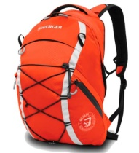

**What should be in your backpack, how to pack it**

**Packing Guidelines**

* Bring a backpack packed with the items below plus some spare room for community food/gear.
* The weight of the fully loaded backpack should rest on the hips, not the shoulders. Gear should be arranged so that weight is closer to the back and higher rather than lower. Gear should secure and not loose. Heavy things high and closest to your back. You are aiming for your pack to weigh 25-30% of your body weight.
* Pack 2-3 liters of drinking water so that it is accessible while hiking.
* If the weather forecast is for rain, bring a backpack cover (in addition to rain gear) to protect your gear. A garbage bag can be used as pack cover if needed. Make sure it fits.
* Bring a small sack/bag with your name on it in which to store personal snack items that go into the bear bag at night. “Smellables” (e.g., scented items like toothpaste), food, garbage, etc., go in the bear bag at night. This “Smellables” bag could be a ziploc bag. The bear bag is hung from a tree.

**Clothes**

* You must wear sturdy hiking shoes/boots with hiking socks - no cotton. Smartwool and sock liners are recommended. NO sneakers! (Old sneakers Blisters and “hot spots” are caused by moisture and friction (movement of your feet and toes in the boot) Having a thin, not cotton, liner sock underneath a heavier smartwool type hiking sock is the best. Pack 2-3 hiking sets (pair of thin socks/pair of thick socks) for the trip. Fresh socks for each day.
* Check to see if you need to bring special/extra equipment for the weather or terrain. For example, if part of hike involves crossing a creek, you want to bring technical sandals, like Teva’s, to keep your hiking boots dry.
* Check your feet: toe nails trimmed 1 week prior to hike, any calluses foot issues need to be identified and corrected before the hike.
* If you are buying new boots, you must wear them continuously for 1 week prior to the trip to make sure they fit and have no mechanical issues. You should break them in on challenging walks with your backpack on as well. (i.e. practice hikes)
* Layers – it should be warm but as the date nears, keep an eye on the weather for rain and chilly temperatures in the higher altitudes.
* Bring a hat for protection against sun, rain, or cold, as the case may be.
* Please see your Boy Scout Handbook and Field Book for more information camping and hiking clothes. Put clothes and other items in Ziploc bags to keep them dry and organized.
* Bring a small towel in case we find somewhere to swim/wade

**Camping equipment**

* Light backpacking tent, but pair up with someone – everyone does not need to bring a tent
* Light backpacking sleeping bag – appropriate for weather forecasted at higher altitudes
* Light backpacking sleeping pad
* Lightweight headlamp (loaded with fresh batteries, and bring extras). I sometimes bring two headlamps in case one breaks.
* You might want to pack a bathing suit. Some scouts do more than just wade in the water if there is any. A ziploc bag to bring a wet bathing suit might not be a ba idea.

**Loading the Pack**

**Weight distribution, in general:**

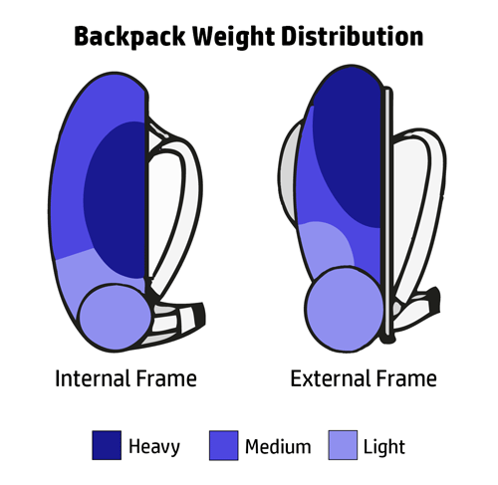

**From REI:**

**Tips for How to Pack a Backpack**

Backpacks can vary widely in size and features, but efficient packing relies on a few common principles. Packing a backpack can be broken down into three zones: the bottom, core, and top of the pack. As you pack, you'll want to consider the weight and shape of each item, as well as how often you need to access your gear.

Ideally, a well-loaded pack will feel balanced when resting on your hips and nothing should be shifting or swaying inside. As you walk, the pack should feel stable and predictable, one with your upper body.

If possible, first pack your backpack at home. You can spread out your gear on a clean floor, visually confirm you've got everything, and feel less rushed as you load up.

Use a checklist to ensure you've got everything you need. (REI offers good checklists for [backpacking](https://www.rei.com/learn/expert-advice/backpacking-checklist.html) and [ultralight backpacking](https://www.rei.com/learn/expert-advice/ultralight-backpacking-checklist.html).) This lessens the chance something gets left behind.

Backpack Access

Most backpacks feature a top-loading opening to reach the main compartment. Some packs also offer a zippered front panel that folds open, exposing the full interior of the pack, or a side zipper, which also makes it easier to reach items deeper in your pack.

Your pack might also feature a sleeping bag compartment, a zippered stash spot near the bottom of the bag. It’s a useful feature if you don’t want to use a stuff sack for your sleeping bag. Alternately, this space can hold other gear that you’d like to reach easily.

Packing the Bottom of Your Backpack

The bottom of the pack is where you should stash items you won't need until you make camp at night. Most backpackers shove their sleeping bag into the bottom of the pack. This is also where you might keep long underwear being used as sleepwear, a pillowcase and a sleeping pad (if it rolls up into a tiny shape).

Any other needed-only-at-night items can go down low *except* a headlamp or flashlight. Always have your light source in a readily accessible space.

In bear country? Try to keep your sleeping bag separated from anything that can transmit a fragrance. Bears can't distinguish between food and non-food aromas, so toothpaste or sunscreen can attract their interest as well as tea bags or jerky.

Packing the Core of Your Backpack

Heavier items should be centered in your pack—not too high, not too low. The goal is to create a predictable, comfortable center of gravity. Heavy items too low cause a pack to feel saggy. Too high and the load might feel tippy.

Your heaviest items should be placed on top of your sleeping bag and close to your spine. Usually these items will be your food stash, water supply and cook kit and stove. If carrying liquid fuel, make sure your fuel bottle cap is on tightly. Pack the bottle upright and place it below your food in case of a spill.

Wrap softer, lower-weight items around the weightier items to prevent heavier pieces from shifting. Your tent body, rainfly, insulation layer and a rain jacket can help stabilize the core and fill empty spaces.

Hydration reservoir: Most newer packs include a hydration reservoir sleeve. This is a slot that holds a reservoir close to your back and parallel to your spine. It's easier to insert the reservoir while the pack is still mostly empty.

Packing the Top and Periphery of your Backpack

Top lid: Many packs offer a zippered top lid. You can stash frequently used items and keep them within easy reach. This might include your map,[compass](https://www.rei.com/c/compasses), [GPS](https://www.rei.com/c/handheld-gps), [sunscreen](https://www.rei.com/c/sunscreen), [sunglasses](https://www.rei.com/c/sunglasses), [headlamp](https://www.rei.com/c/headlamps), [bug spray](https://www.rei.com/c/insect-repellent), [first-aid kit](https://www.rei.com/c/first-aid-kits), snacks, rain gear, [packcover](https://www.rei.com/c/pack-rain-covers), toilet paper and sanitation trowel. You can also place these in external pockets, if you have them. Some packs even offer small pockets on the hipbelt.

Sleeping pad: You may need an extra set of straps to attach it to a lash point on the top of the pack or near your waistline on the outside of the pack. Another option: put it beneath your top pocket (lid) and the top opening of the pack, then tighten the lid to the pack. The pad may be vulnerable to slipping out either side, so secure the pad to the pack with an extra strap or two. (Note: It's fine to carry tent poles and a sleeping pad inside a pack if you have the space.)

Tent poles: If your pack offers elasticized side pockets, place the poles down one side of the pack, behind one or more compression straps, with one end of the poles in the pocket.

Trekking poles: Same deal; just put the grips in the pocket and the tips pointing upward.

Note: Minimize the amount of gear you attach to your pack's exterior. External items can potentially get snagged on brush in areas of dense vegetation. Too much external gear could also jeopardize your stability.

Other Tips for Packing a Backpack

Fill up all empty spaces. For example, put utensils, a cup or a small item of clothing inside your cooking pots. Fill up your bear canister.

Stuff sacks: Some may prefer the low-chaos/easy-organization of stuff sacks, while others simply prefer to pack soft items loosely in the pack to use up all available room. Experiment with your own gear and decide which method most appeals to you.

Share the weight of large communal items (e.g., tent) with others in your group. You carry the main body, for example, and your friend can carry the poles and rainfly.

Compression straps: Tighten all compression straps to limit load-shifting.

Rain cover: Carry a [pack rain cover](https://www.rei.com/c/pack-rain-covers) and keep it easily accessible. Though some backpacks are made with waterproof fabric, they have seams and zippers that are vulnerable to seepage during a downpour. A pack cover is worth its weight when rain becomes persistent.

Repair items: Wrap strips of duct tape around your water bottles or trekking poles just in case; if a strap pops or some other disaster occurs, a quick duct tape fix could keep you going. Take along a few safety pins in case a zipper fails.

Link to You Tube video from REI describing how to pack a backpack (I am sure there are thousands more):

<https://www.youtube.com/watch?v=HB7ZOjnnFS8>

How to put a pack on properly:

<https://www.youtube.com/watch?v=SwgYrYqc_H0>

How to put on a heavy pack by yourself:

<https://www.youtube.com/watch?v=qH0-4rNyBEA>

Personal Backpacking Packing List

Quantities are just a guide. Make your own reasonable decisions.

|  |  |  |  |  |  |  |  |  |
| --- | --- | --- | --- | --- | --- | --- | --- | --- |
| **Chk** | **Equipment** | **QTY** | Comments |  | **Chk** | **Equipment** | **QTY** | Comments |
|  | **UPPER BODY LAYERS** |  |  |  |  | **FOOTWEAR** |  |  |
|  | Base Layer (mid-wgt) | 1 |  |  |  | Boots/Trail shoes/running shoes | 1 pair |  |
|  | Middle Layer (fleece | 1 |  |  |  | Socks | 2 pair |  |
|  | Top Layer (synthetic jacket) | 1 |  |  |  | Liner Socks | 2 pair |  |
|  | Rain Jacket | 1 |  |  |  | Camp Shoes |  |  |
|  | Shirt - Short Sleeve | 1 |  |  |  |  |  |  |
|  | Shirt - Long Sleeve | 1 |  |  |  | **MISCELLANEOUS ITEMS** |  |  |
|  | Sports Bra |  |  |  |  | Bowl | 1 |  |
|  | **LOWER BODY LAYERS** |  |  |  |  | Mug /Cup | 1 |  |
|  | Base Layer (mid-wgt) | 1 |  |  |  | Spoon/Spork | 1 |  |
|  | Rain Pants | 1 |  |  |  | Water Bottles/ 1-QT/Lt. | 3 |  |
|  | Long Pants | 1 |  |  |  | Pocket Knife | 1 |  |
|  | Underwear | 1 |  |  |  | Matches/Lighter | 1 |  |
|  | Hiking Shorts | 1 |  |  |  | Flashlight/Headlamp | 1 |  |
|  | **HEAD, NECK & HAND** |  |  |  |  | Map | 1 |  |
|  | Wool or fleece hat | 1 |  |  |  | Compass | 1 |  |
|  | Glove liners or mittens | 1 |  |  |  | Bandanas/tubular headwear |  |  |
|  | Baseball cap or wide brim | **1** |  |  |  | Money | $25 |  |
|  | **PACKS AND BAGS** |  |  |  |  | Lip Balm | 1 |  |
|  | Backpack | 1 |  |  |  | Soap, biodegradable | 1 |  |
|  | Summit/Daypack |  |  |  |  | Toothbrush | 1 |  |
|  | Lashing Straps |  |  |  |  | Toothpaste | 1 |  |
|  | Gallon Ziploc Bags |  |  |  |  | Camp Towel | 1 |  |
|  | Pack Cover | 1 |  |  |  | Tampons/Pads |  |  |
|  | Small Stuff Sacks |  |  |  |  | Sunglasses | 1 |  |
|  | Ditty Bags |  |  |  |  | Watch | 1 |  |
|  | **SLEEPING GEAR** |  |  |  |  | Camera/Phone | 1 |  |
|  | Sleeping Bag | 1 |  |  |  | Whistle |  |  |
|  | Waterproof Stuff Sack |  |  |  |  | Fishing Equipment |  |  |
|  | Sleeping Pad | 1 |  |  |  | Fishing License |  |  |
|  | Sleep Clothes | 1 set |  |  |  | Postcards |  |  |
|  |  |  |  |  |  | Foot powder |  |  |
|  | **MEDICAL FORMS PERMISSION SLIP IN 1 GAL. ZIP LOC BAG** |  |  |  |  | Notepad and pen |  |  |
|  |  |  |  |  |  | Toilet Paper |  |  |

Crew Gear List-**Quartermaster must check EVERY item before crew bear is distributed**

|  |  |  |  |  |  |
| --- | --- | --- | --- | --- | --- |
|  | **Category** | **Issued** | **Returned** | **Description** | **Notes** |
| 1 | Gear List |  |  | 2 Copies of Gear List in ZIPLOC's |  |
| 2 | Bear Bag Gear |  |  | 3 kitchen trash bags / 3 drum liners in ZIPLOC |  |
| 3 | Bear Bag Gear |  |  | Caribiner |  |
| 4 | Bear Bag Gear |  |  | 4 x 50' Paracord Bundles |  |
| 5 | Kitchen |  |  | 8 Quart Pot |  |
| 6 | Kitchen Ditty Bag |  |  | Tyvek Tarp - 2 Dinner Tables in ZIPLOC |  |
| 7 | Kitchen Ditty Bag |  |  | Campsuds Bottle |  |
| 8 | Kitchen Ditty Bag |  |  | Pot Scrapper - MSR Red/Black |  |
| 9 | Kitchen Ditty Bag |  |  | Pot Holder/Lid Lifter |  |
| 10 | Kitchen Ditty Bag |  |  | Sponge/Scrubber in ZIPLOC |  |
| 11 | Kitchen Ditty Bag |  |  | Strainer - Black Screen in ZIPLOC |  |
| 12 | Kitchen Ditty Bag |  |  | Spoon - Flat Bottom Cooking |  |
| 13 | Kitchen Ditty Bag |  |  | Water Purification Pills in ZIPLOC |  |
| 14 | Sanitation Ditty Bag |  |  | Hand Sanitizer - 4 Fluid OZ |  |
| 15 | Sanitation Ditty Bag |  |  | Trowel - Steel |  |
| 16 | Sanitation Ditty Bag |  |  | Spike/Stake - Yellow Plastic |  |
| 17 | Sanitation Ditty Bag |  |  | Toilet Paper - RV/ Biodegradable in ZIPLOC |  |
| 18 | Stove |  |  | Fuel Bottle with Stove Valve |  |
| 19 | Stove Ditty Bag |  |  | Stove |  |
| 20 | Stove Ditty Bag |  |  | Foil Heat Shield Disc |  |
| 21 | Stove Ditty Bag |  |  | Foil Wind Shield |  |
| 22 | Stove Ditty Bag |  |  | ZIPLOC: Lube, Nozzle, Oring, Directions |  |
| 23 | Stove Ditty Bag |  |  | Fuel Bottle Cap |  |
| 24 | Tarp |  |  | Tarp |  |
| 25 | Tarp |  |  | 3 x 50' Paracord Ridge/Side Lines |  |
| 26 | Tarp |  |  | Stakes |  |
| 27 | Tarp |  |  | Poles, Tent - 2 Shelter Ends |  |
| 28 | Trip Gear |  |  | Spare Stove Valve |  |
| 29 | Trip Gear |  |  | Sewing Kit |  |
| 30 | Trip Gear |  |  | Platypus 4 Liter Water Filter |  |
| 31 | Trip Gear |  |  | Foot Print Kit - Plaster of Paris/Cups |  |
| 32 | Trip Gear |  |  | Water Containers |  |
| 33 | Trip Gear |  |  | First Aid Kit - Part 1 |  |
| 34 | Trip Gear |  |  | First Aid Kit - Part 2 |  |
| 35 | Trip Gear |  |  | First Aid Kit - Part 3 |  |

Image result for squirrel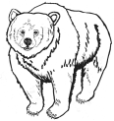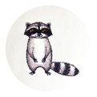Image result for chipmunk

**Bear Bags**

Smellables—What is a smellable?

The Philmont definition: A **smellable** is an item (food or non-food) with an odor that might attract a bear. The odor may or may not be apparent to humans and might even be described as "scent-free". ALWAYS hang anything that you are unsure about.

An **incomplete** list:

• Lotion, sunscreen, chap stick

• Deodorant (probably won’t be bringing this

on the trail anyway)

• Soap of any kind

• Medicine, even basic pills

• Matches/lighters

• Water bottles that have been used with drink

mix (it is recommended that you use only 1

water bottle for mixing)

-First Aid kit supplies

-A water bottle that had something other than water put in it

• All food, eating and cooking utensils and

pots, of course

• Any clothes that food (or any other

smellable) has been spilled on significantly

• Toothbrush, toothpaste

• Camera film

• Pocket rocket and fuel

• Bug spray

• Trash (wrappers, etc.)

Each individual should have their own separate bag(s): one or large plastic baggies with your name on them works fine, so that at the end of the day it’s easy to put everything in the group bear bag.

For each group bag, you need 50-100 feet of 1/8 to ¼ inch braided nylon rope (it should be able to carry a heavy weight load). You also need a waterproof, sturdy bag (needs to hold a lot of weight without breaking), and a heavy duty, climbing quality carabiner.

There are many different ways to hang a bear bag, each with advantages and disadvantages. This guide will describe a few:

**Single Tree Branch Bear Bag Method**

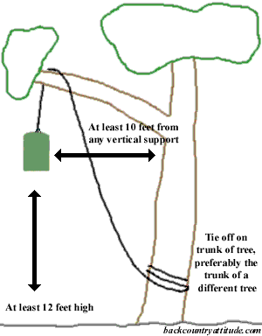

**Two Tree Bear Bag Method**

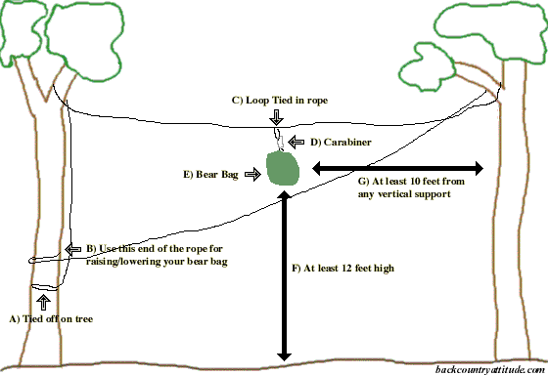

**Instructions for two tree method:**

A) 1 end of the cord secured to the tree.

B) The other end will be the end to lower or raise your bear bag. If short on cord you can secure this end onto the other tree. If you let go of the rope the bag may come tumbling downward. When bringing the bag down make sure your cord does not get so elevated that you wont be able to reach it.

C) I tie a loop in the cord to so it's simpler to attach my bear bag.

D) Use biner to attach your bear bag to the loop on the cord.

E) Pack any items with an odor into the bear bag.

F) Hang the bear bag a minimum 12 ft up.

G) Hang the bag a minimum of 10 ft from vertical supports.

More about bear bags and the campsite--double click pdf page below to open file:



Things that can go wrong…

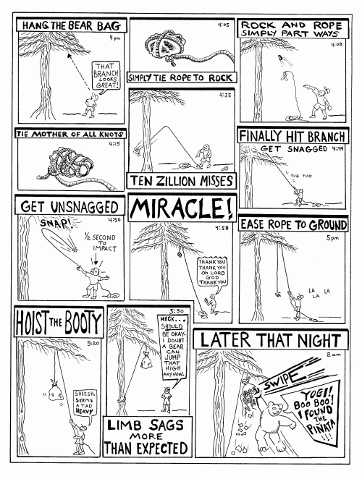



**“Going” in the Woods**

Some basic rules:

* Hole should be 200 feet (if possible) from camps, trails, water, and dry gullies.
* Dig a hole 6-8 inches deep, and 6 inches wide.
* Take care of business.
* Put dirt on back on top of the waste and toilet paper
* Cover with leaves
* It is sometimes nice to put a stick in the ground net to the where the hole was, to let others know that spot is “taken”.
* **Important note:** **THE TROWEL NEVER TOUCHES THE POO!!!!!** You should use a stick maneuver poo into the hole if you missed, which happens a lot. If you don’t have time to dig a hole, poo first, dig later, no biggie! But trowel should come nowhere near the poo.

**Positions:** There three basic positions for answering nature's call in the backcountry. It’s the most natural thing in the world. Don’t let a lack of indoor plumbing prevent you from camping overnight.

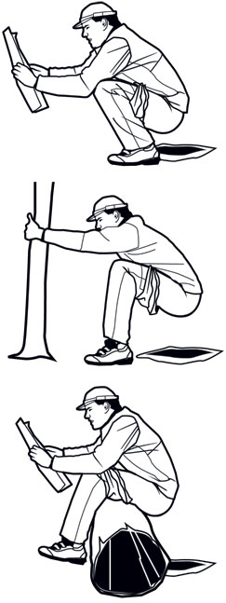

The Squat

The original outdoor pooping stance: Dig a hole (6 inches deep, 200 feet from water, camp, and trails) and squat. You may want to hold your knees

The Tree Hug

It’s not just for hippies: Dig your hole a foot away from the base of a tree, then hold the trunk for support. Whatever you do, don’t let go.

for

The Butt Hang

A boulder or fallen log can double as a toilet seat.

support.

*From Backpacker Magazine*

Other notes and additional notes on hygene, and **some important considerations for women** can be found in the BSA Field Book (5th edition, pages 93-95).

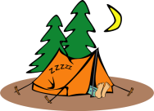

**Camp Set Up**

Camp set up generally involves keeping tents, cooking areas, backpacks, and the bear away from each other.

Tents should be set up in as as flat area as possible, and in any area that will not be a puddle or a river in rainstorm.

Check above for widow makers: dead branches or trees that could fall on the tent.

A good general idea from how to set up camp is shown in the following diagram,:

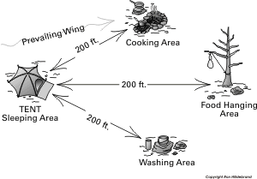

10-20 feet

Backpacks

Some additional notes:

* Note that smellable areas are downwind of tent area
* We usually keep food and washing areas together, with maybe a sump-hole in a different location.
* Backpacks should also be stored 10-20 feet away from tents, under a tarp or dining fly.
* Sometimes these distances are not practical in camp sites, but the general idea keeping food and smellable areas a good distance away from tents is important.
* The bear bag is the most important item to keep far way, and downwind, of camp.



**Water Purification**

The crew uses two types of water purification systems to purify water twice: First, the Platypus Gravity Works water filtration system is used, and then chemical purification with chlorine dioxide (either Katadyn or Aquamira brand) water purification tablets is used. Occasionally iodine tablets are used, but care needs to be taken when using this method, because some people have iodine allergies. It should be noted it is not really necessary to use both of these methods to purify water in our area. We do this as a an extra precaution.

Some additional notes:

* In both methods, care must be taken to make sure that the water is as free from debris as possible. Sometimes you can “prefilter” the water though a bandana to remove debris.
* If you are going to use boiled water for cooking, no other water purification method is needed other than boiling the water for 3-5 minutes.
* Figure out how much water you need by figuring out how much water you have on hand (gather everyone together and get an assessment), and how much you need: cooking cleaning for this day and the next morning, and 2-3 liters of water for each person on the next day’s hike.
* **ALWAYS be EXTREMELY CAREFUL to separate purified (1st step and 2nd step) and unpurified water, so that you don’t get them confused.** Giardia poisoning is extremely unpleasant and can last for months. When in doubt, ALWAYS repurify!

**Platypus Gravity Works water filtration system:**

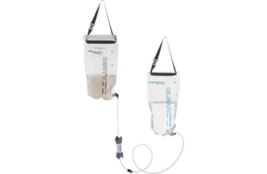

Please see full pdf instructions in Appendix C.

Here is a quick video to give you an idea of how to use it, there are many more if you want more info:

<https://www.youtube.com/watch?v=1KVNtjNJsc4>

**Water purification tablets:**

Instructions are on tablet package. Ingeneral at tablet to container with water (usually one tablet per liter, but read instructions) let tablet dissolve for 15 minutes. Shake container to mix. Now slightly loosen threads of bottle cap about half way. Briefly invert bottle to let water flood the threads of the bottle. You will know this is happening when you see water leaking out of the cap area of the inverted bottle. Now, with bottle right side up, close bottle cap and let water sit for 4 hours to fully purify

.



**Backpacking Stove Operation**

The ability to use a backcountry camping stove is not difficult, but it requires a little practice, and is better learned by doing, rather than reading instructions or seeing a video. That being said, the information below can be very useful in getting you started in the process.

There are many kinds of backpacking stoves. Our Crew uses an MSR Whisperlite stove, which looks like this when fully assembled:

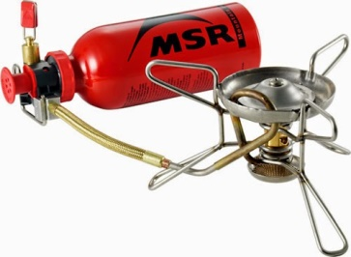

The printed instructions on how to use a Whisperlite stove, which is the type of backpacking stove we use, are located in appendix D

Here is link to a you-tube video, showing how to use a Whisperlite stove

<https://www.youtube.com/watch?v=qzNgu8lFreY>

There many videos like this on you tube. It might be useful to use more than one.

A few additional notes about stove usage that might be somewhat unique to our crew:

* **The fuel pump assembly is always kept screwed on to the fuel bottle**. This keeps dirt out of the bottle and the pump apparatus, and protects the delicate fuel pump parts from getting broken.
* Wind Screen should not be creased sharply when putting it away. Folds should be “rounded and not sharp. Creasing it will weaken and eventually break the metal.
* Stove instructions are purposely kept attached to the pump (to not lose them), but they need to protected from the flame when starting the stove.



**SEMPER GUMBY!!!**

It is very important to remember that circumstances will always change to some degree: Before the trip the number of people may change, the number of drivers may change, weather conditions may change. There may be things that happen during the outing that may cause you to adjust plans as you go. This almost always happens. Just remember to be like Gumby and STAY FEXIBLE! Adjust the plan to accommodate these changes. When you do this, you can stay safe, and lots of fun will still happen!

Appendix A: Venturing Risk Management Plan PDF—**double click to open**



Appendix B: BSA Medical Forms—double click to open



--------------------------------------------------------------------------------------------------------------------------

Appendix C. Platypus Filtration system instructions—double click to open



------------------------------------------------------------------------------------------------------------------------------

Appendix D: Whisperlite Stove Manual from MSR---Double click to open



------------------------------------------------------------------------------------------------------------------------------------

**Additional Resources**

Boy Scouts of America Handbook

Boy Scouts of America Field book

Allen and Mikes Really Cool Backpackin' Book

Backpacker magazine recipes site (a LOT of very good recipes): <http://www.backpacker.com/skills/cooking/recipes/>